**Program 10 :Find the difference between maximum and minimum number from a list.**

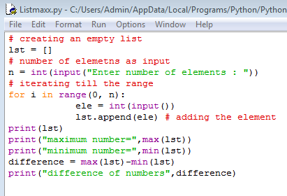

**OUTPUT:**

